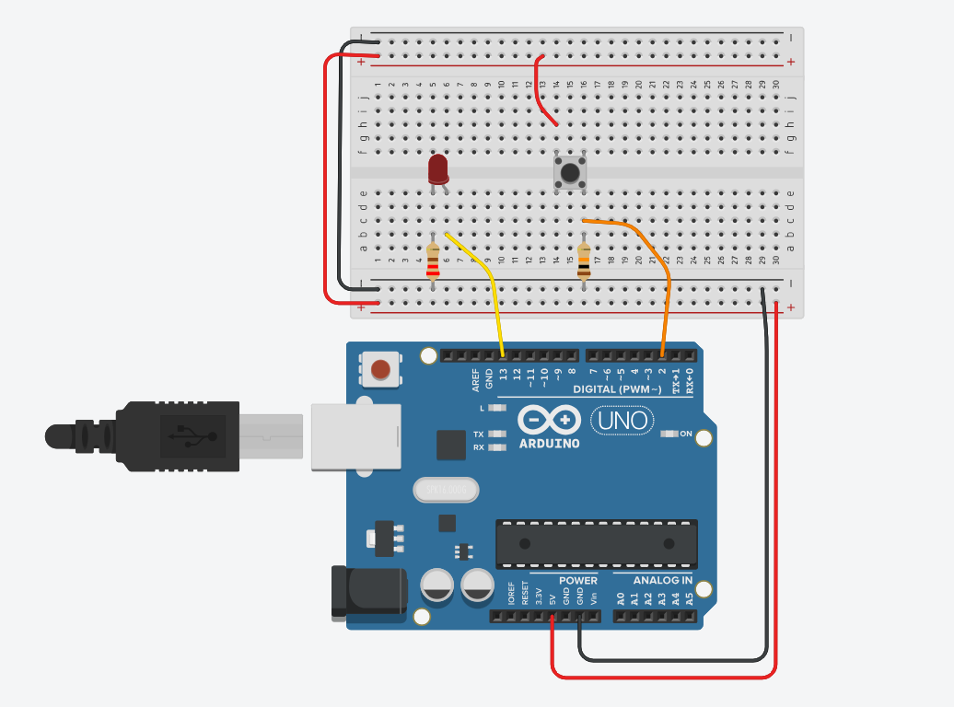
int buttonState = 0;

void setup()
{
pinMode(2, INPUT);
pinMode(LED_BUILTIN, OUTPUT);
}

void loop()
{
// read the state of the pushbutton
buttonState = digitalRead(2);
// check if pushbutton is pressed. if it is, the
// button state is HIGH
if (buttonState == HIGH) {
digitalWrite(LED_BUILTIN, HIGH);
} else {
digitalWrite(LED_BUILTIN, LOW);
}
delay(10); // Delay a little bit to improve simulation performance
}
Conclusion : The push button experiment in Arduino demonstrated that a button can provide a simple digital input to the microcontroller. When the button is pressed, the input state changes, allowing the Arduino to trigger actions such as turning an LED on or off. This confirms that push buttons are reliable components for user-controlled inputs in electronic circuits.

